

**Front - End UI/UX Mini Project**

**Product Launch Page**

1. **Title Page**

* **Project Title:** *Product Launch Page*
* **Submitted By**: 
  + *2462323 - Darren Samuel D’Cruz -* [*darren.samuel@btech.christuniverityuniversity.in*](mailto:darren.samuel@btech.christuniverityuniversity.in)
  + *2462345 - P. Kamuel Shawn -* [*p.kamuel@btech.christuniversity.in*](mailto:p.kamuel@btech.christuniversity.in)
  + *2462333 - Joel Jacob Roji -* [*joel.jacob@btech.christuniversity.in*](mailto:joel.jacob@btech.christuniversity.in)
* **Course**:  *UI/UX Design Fundamentals*
* **Instructor Name**: *Mrs. Nagaveena*
* **Institution**:  *Christ (Deemed – to – be) University*
* **Date of Submission**: *12/08/2025*

**2. Abstract**

This project focuses on the design and development of a responsive front-end launch page for **PulsePro X**, a next-generation smart gadget. The webpage was created using semantic HTML5 and CSS, with a strong emphasis on clean visual hierarchy, intuitive navigation, and modern UI/UX practices. Key features include a fixed navigation header, a visually impactful hero section, interactive feature and pricing cards, a detailed specifications table, and testimonial highlights. Flexbox layouts and responsive design principles ensure the page adapts seamlessly to different devices, providing an optimal viewing experience on desktops, tablets, and mobiles.

**3. Objectives**

* Design a user-friendly interface using modern UI principles
* Develop a fully responsive layout using only HTML and CSS
* Implement structured HTML5 semantic elements
* Apply CSS styling for branding, layout, and responsive behavior
* Ensure accessibility and readability across all devices

**4. Scope of the Project**

* Focused on front-end design only
* No JavaScript or server-side integration
* Intended for desktop, tablet, and mobile viewports
* Used only open-source tools and pure code (no libraries)

**5. Tools & Technologies Used**

|  |  |
| --- | --- |
| Tool/Technology | Purpose |
| HTML5 | Markup and content structure |
| CSS3 | Styling and layout management |
| VS Code | Code editor |
| Google Fonts | Typography |

**6. HTML Structure Overview**

* <header> - fixed top navigation with logo and anchor links.
* <section id="hero"> - hero area (headline, short pitch, image).
* <section id="features"> - feature cards showcasing product strengths.
* <section id="specifications"> - a specification table for technical details.
* <section id="testimonials"> - user testimonials and ratings.
* <section id="pricing"> - pricing plans and CTAs.
* <section id="cta"> - final call-to-action (buy now).
* <footer> - copyright and additional links.

**7. CSS Styling Strategy**

* Used external CSS file (style.css)
* Organized with comments and sections
* Techniques used:
* Flexbox for horizontally aligned sections.
* Responsive wrapping using flex wrap and max-width constraints on cards.
* Accessible fonts using google fonts
* Visual hierarchy via larger type for headings and contrasting button colors.

**8. Key Features**

|  |  |
| --- | --- |
| Feature | Description |
| Responsive Design | Adapts seamlessly to all screen sizes |
| Smooth Navigation | Fixed top nav with anchor links |
| Project Cards | Flex-based layout with hover effects |
| Accessible Fonts & Colors | High contrast and readable typography |

**9. Challenges Faced & Solutions**

|  |  |
| --- | --- |
| Challenge | Solution |
| Overlapping elements on small screens | Used media queries to stack elements |
| Difficulty aligning items using float | Shifted to Flexbox and Grid |
| Typography scaling issue | Used relative units (em/rem) instead of px |

**10. Outcome**

* Achieved a clean, consistent, and visually engaging front-end layout
* All key components function as intended using just HTML and CSS
* Learned about layout responsiveness and UI hierarchy in depth

**11. Future Enhancements**

* Add JavaScript for interactive behaviors (mobile nav toggle, modal product previews)
* Integrate animations or transitions
* Backend integration for payment
* Theme toggler (light/dark mode)

**12. Sample Code**

* **HTML code:**

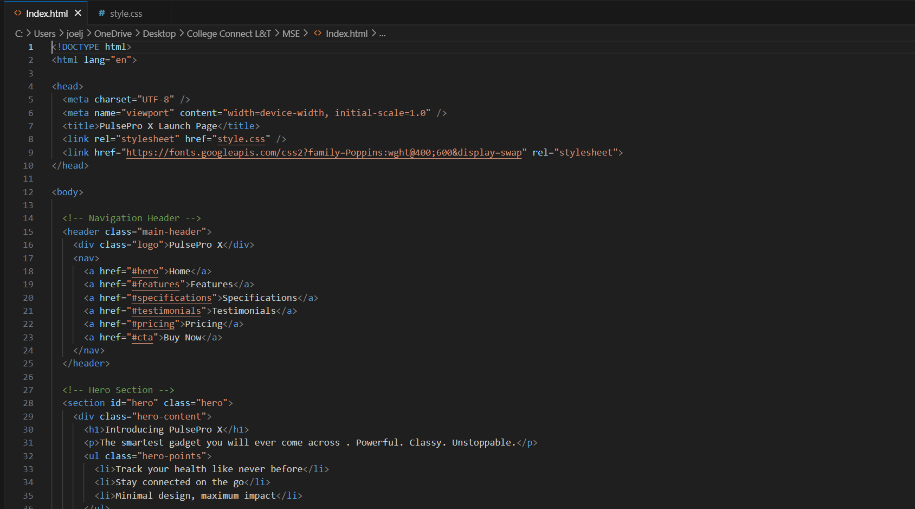 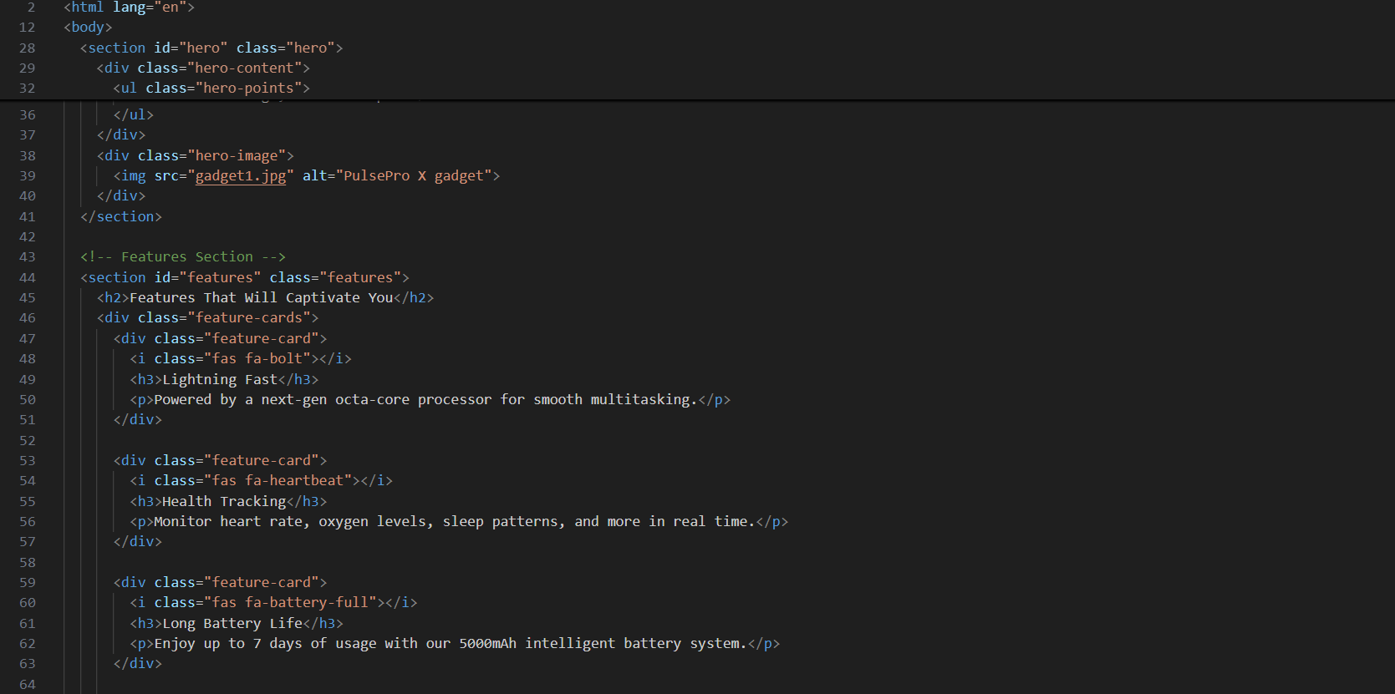 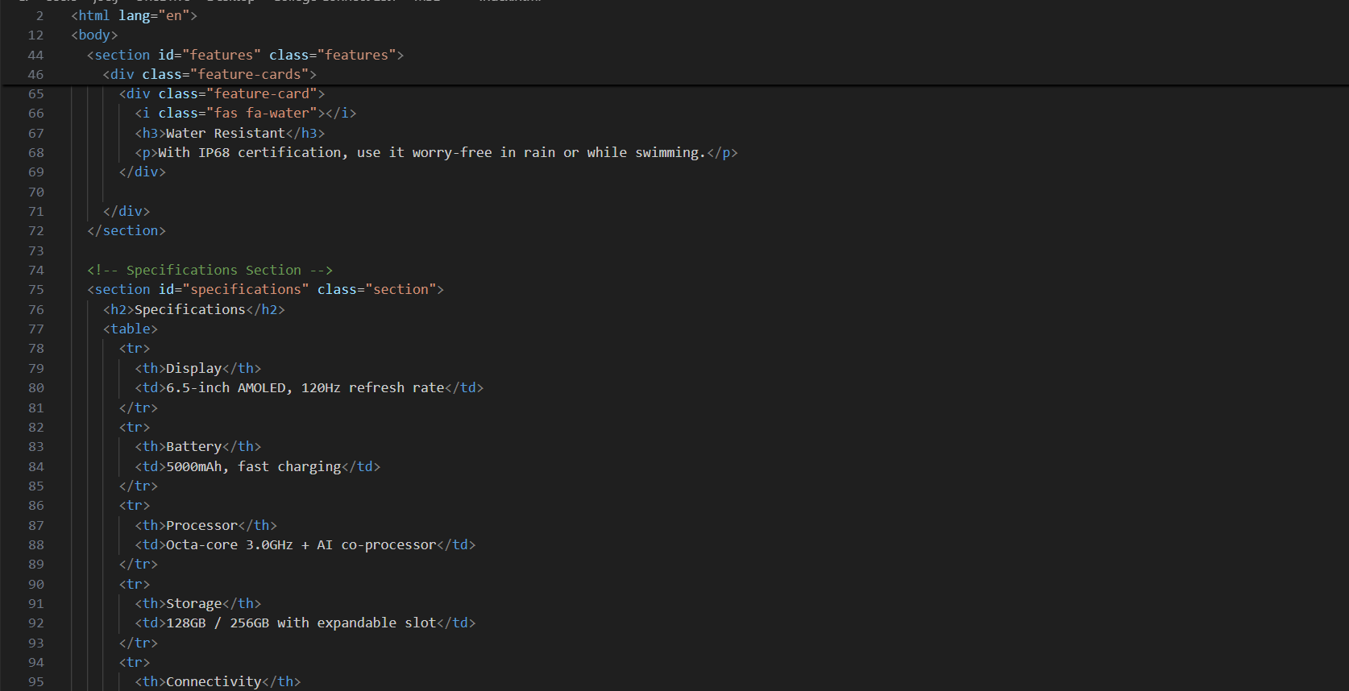 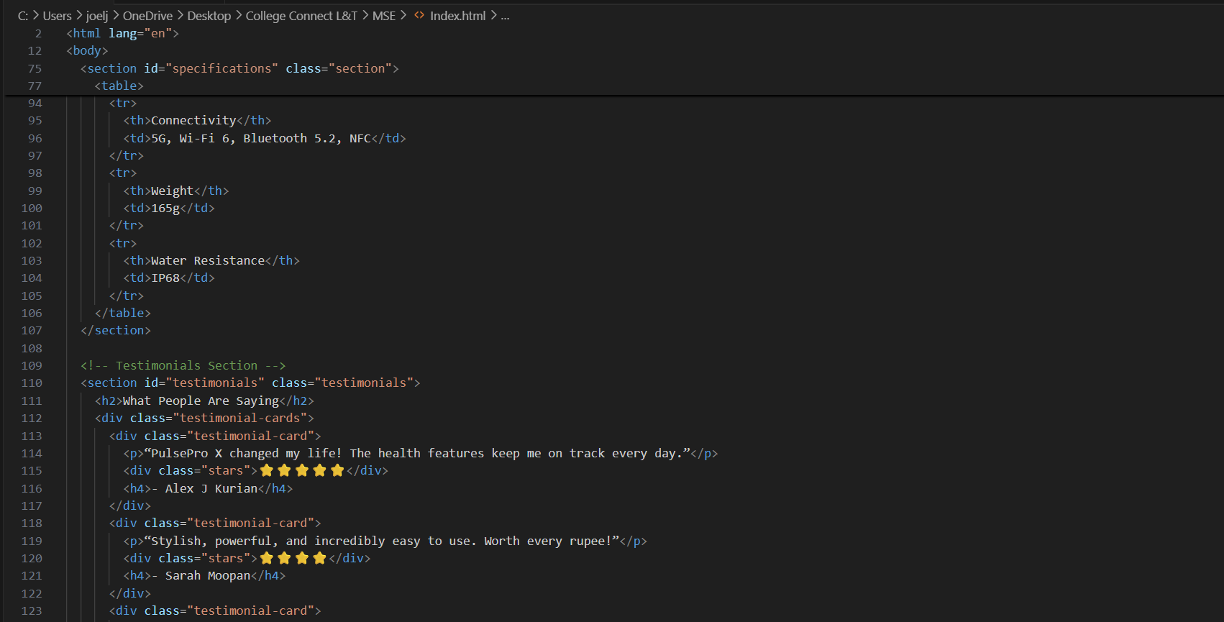 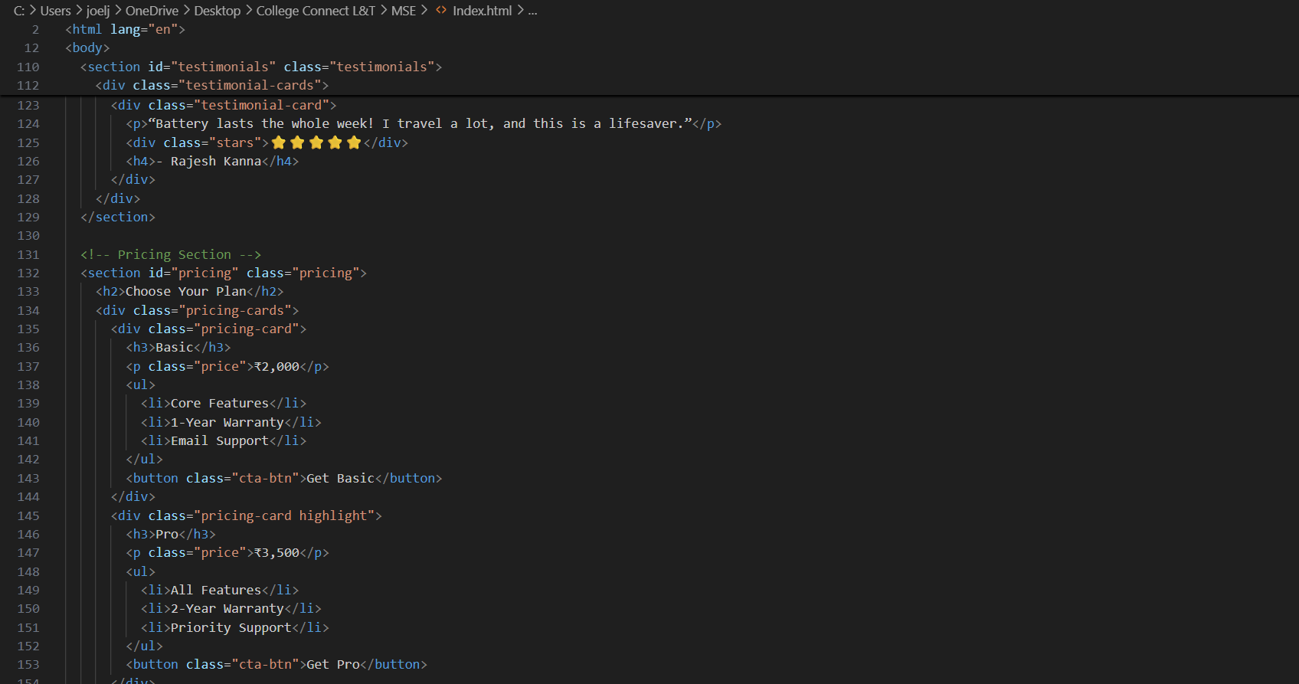 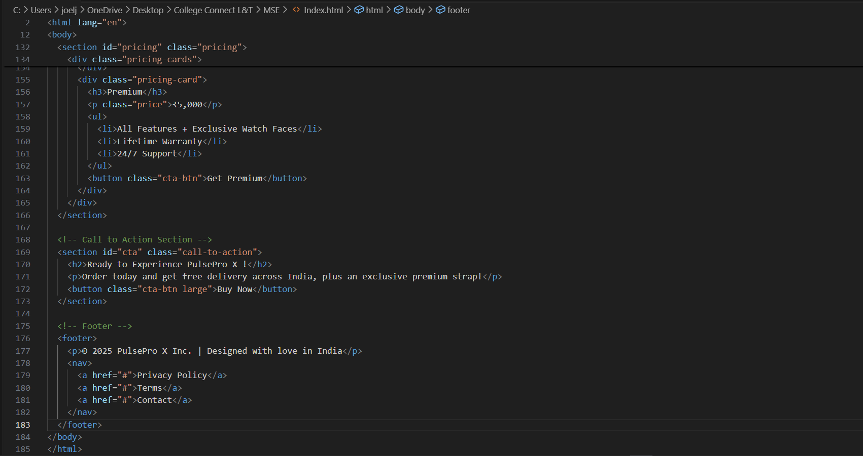

* **CSS Code:**

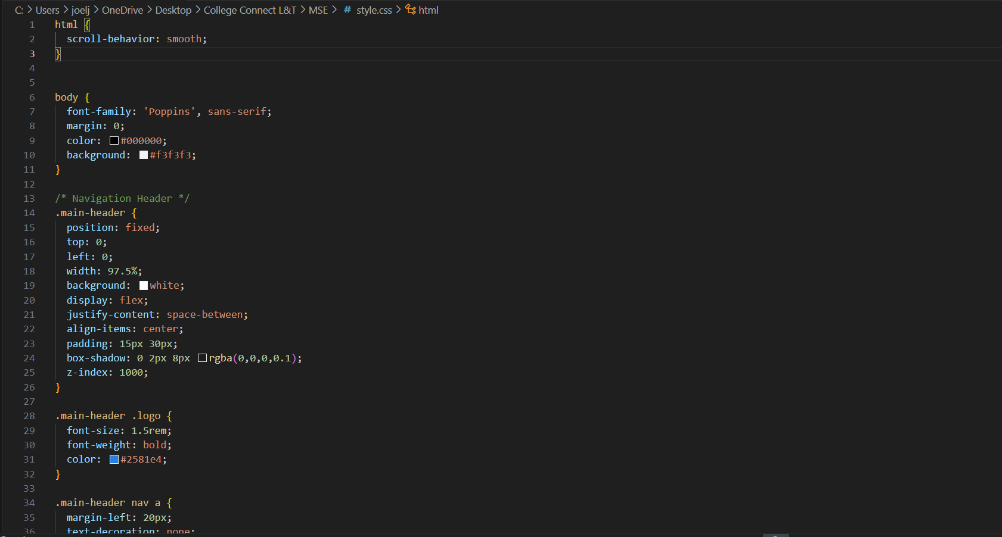 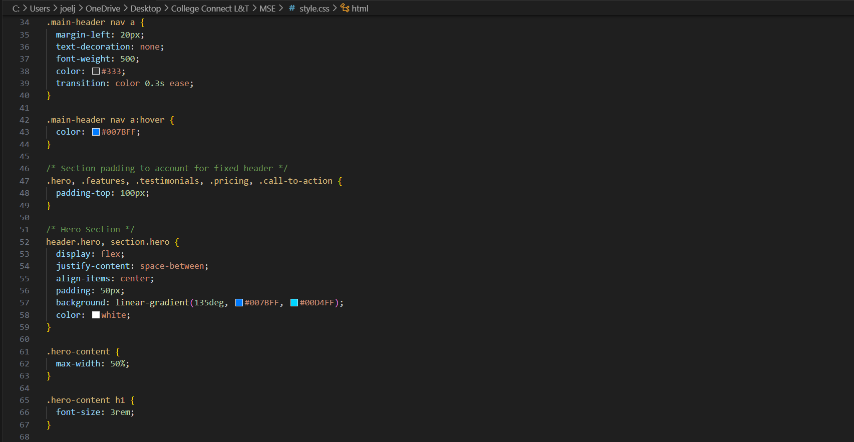

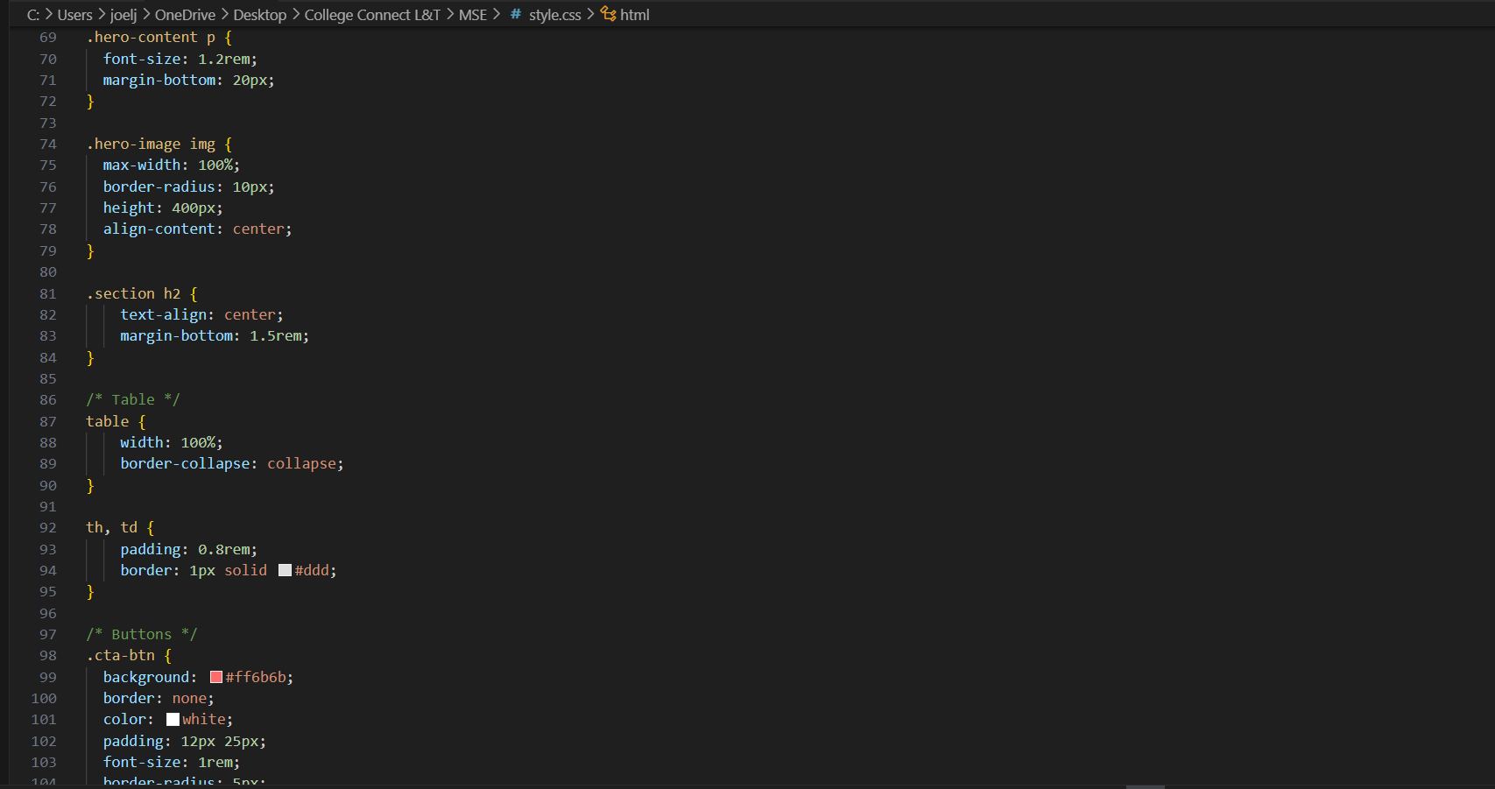 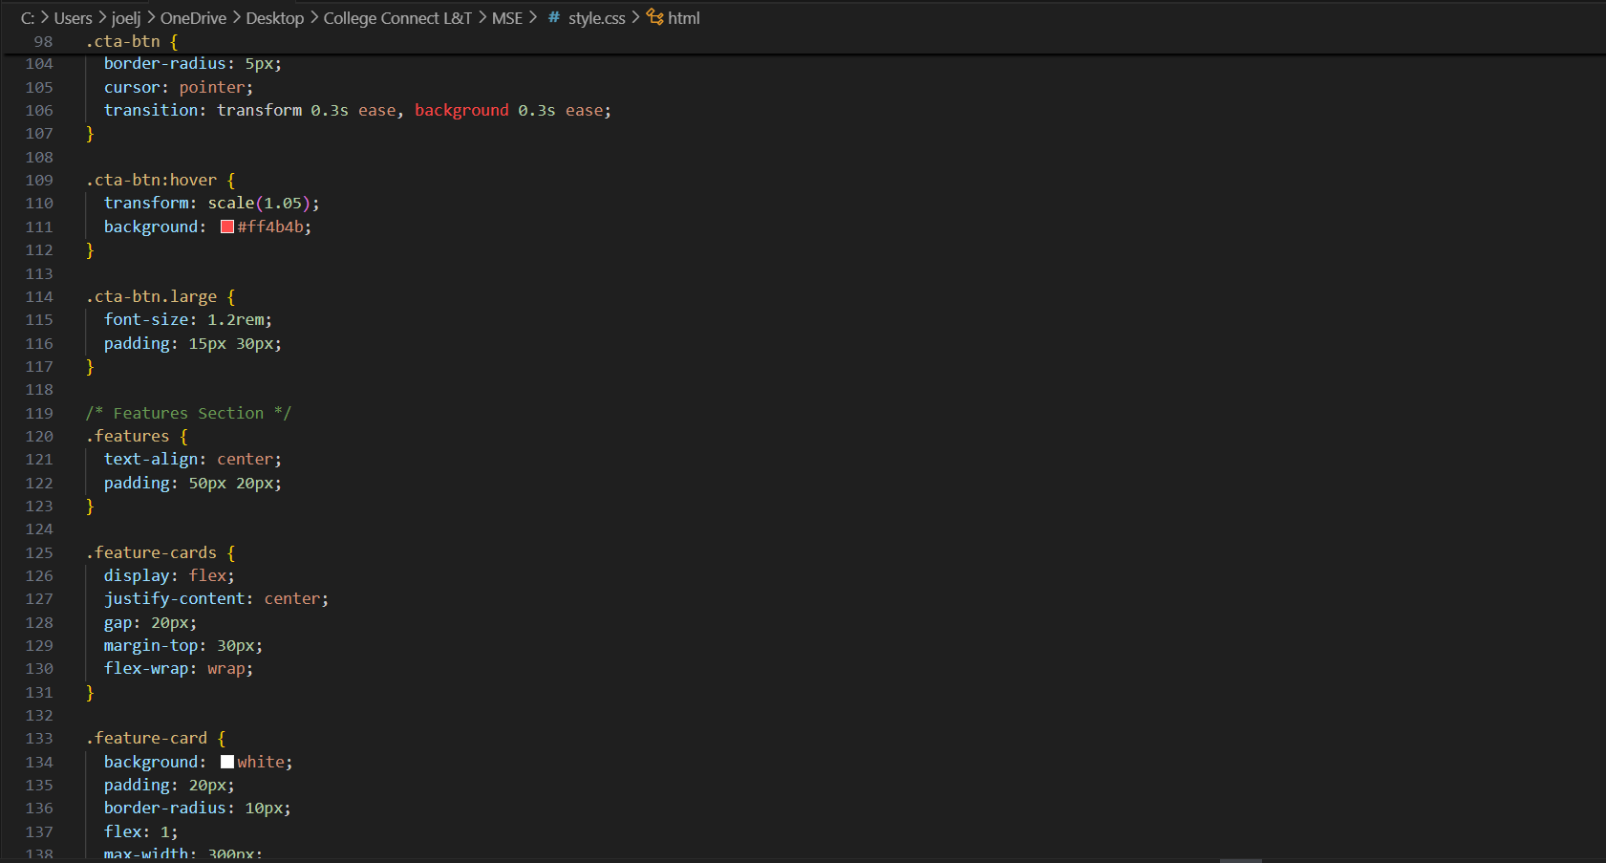 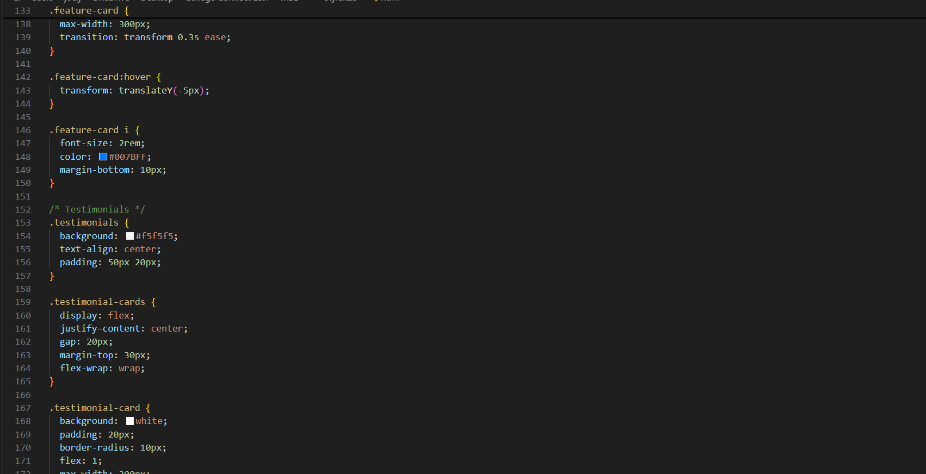 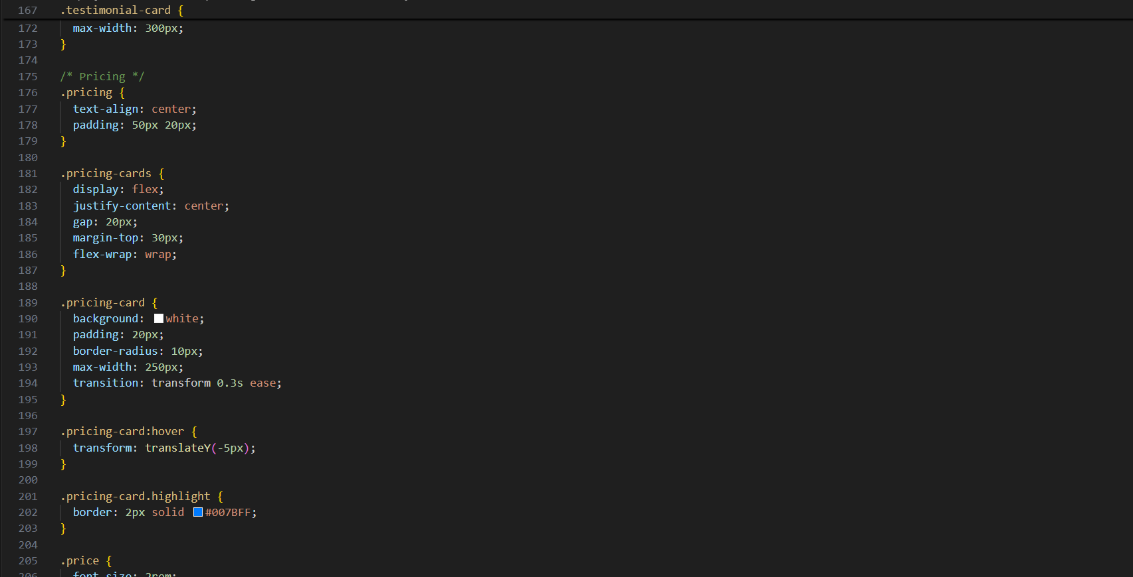

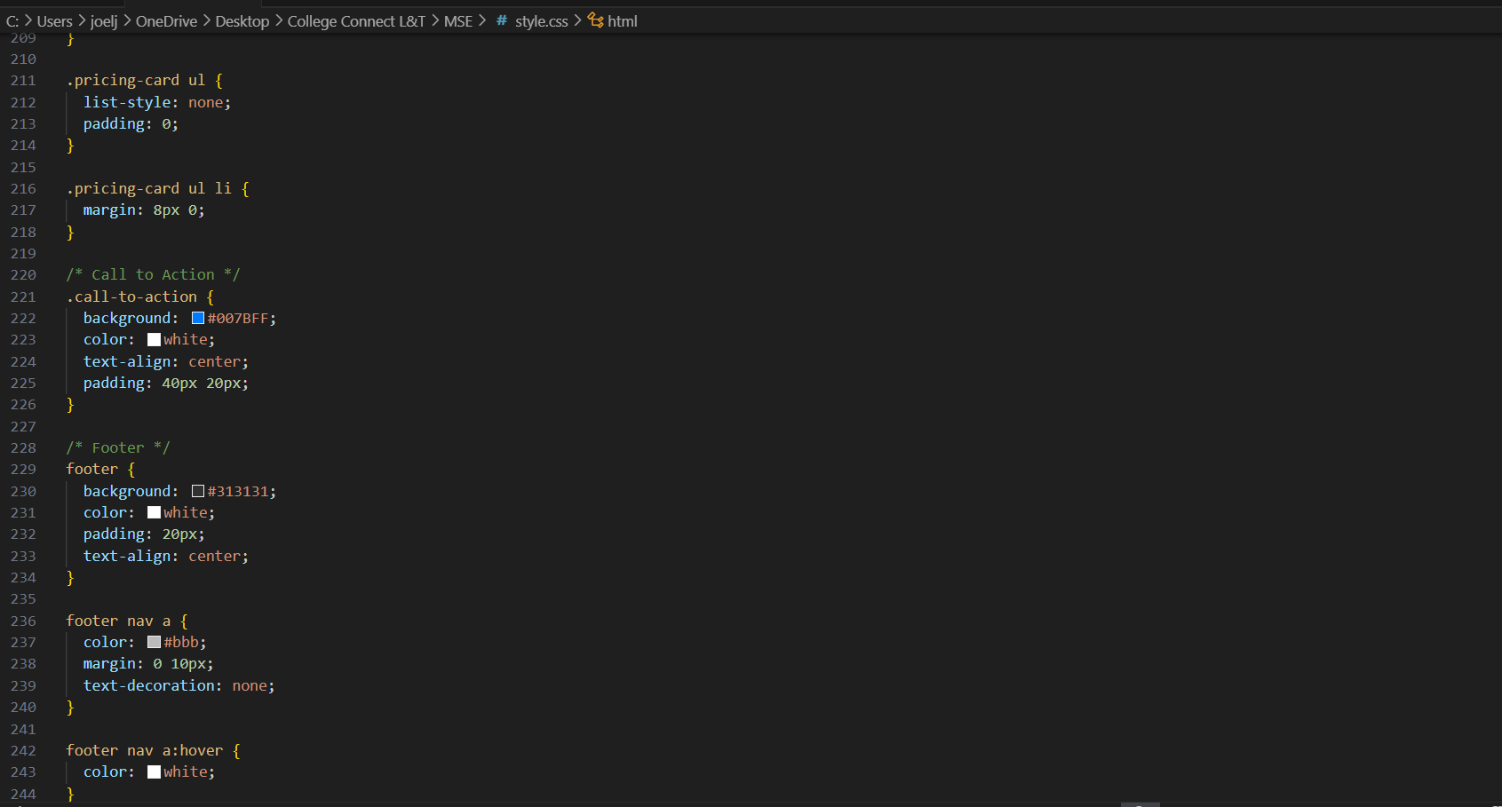

**13. Screenshots of Final Output**

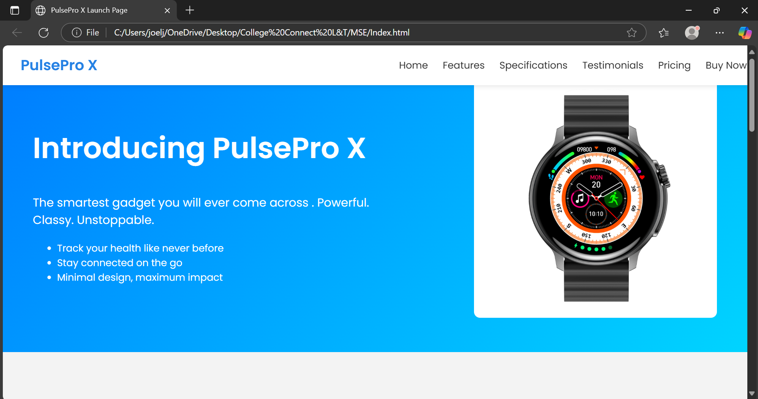 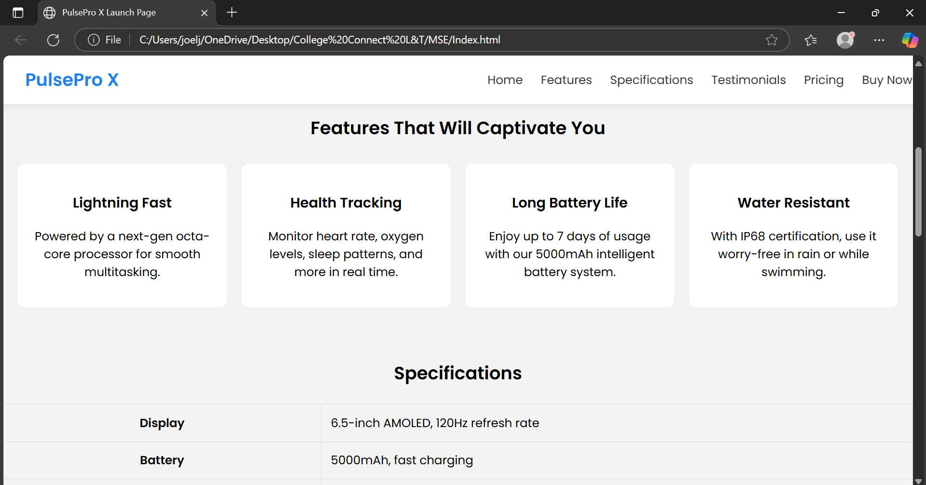

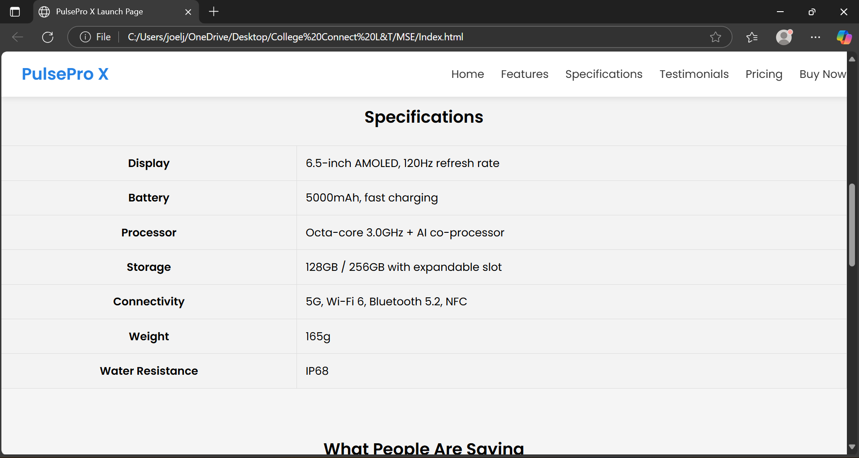 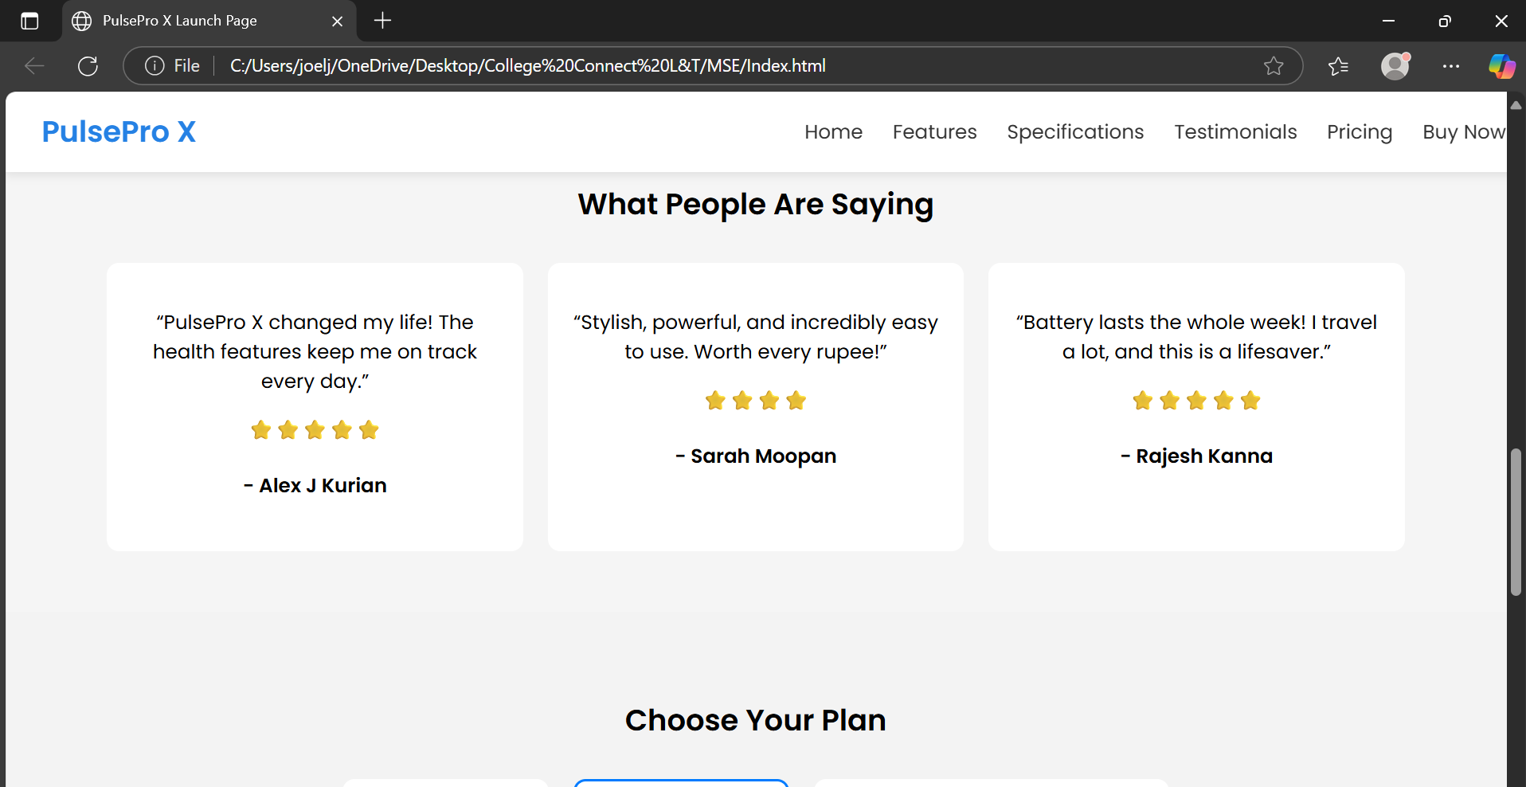

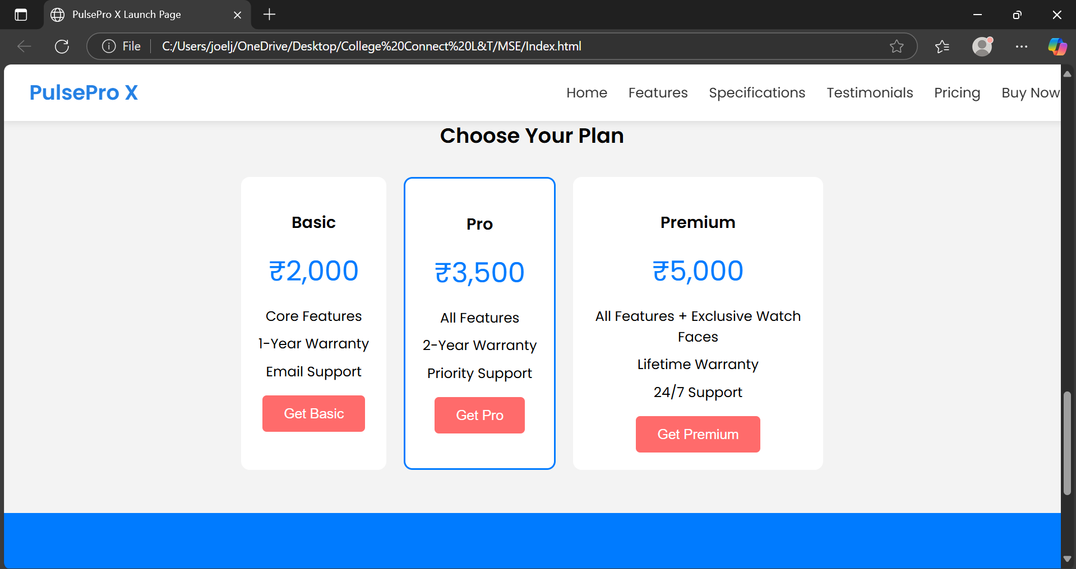 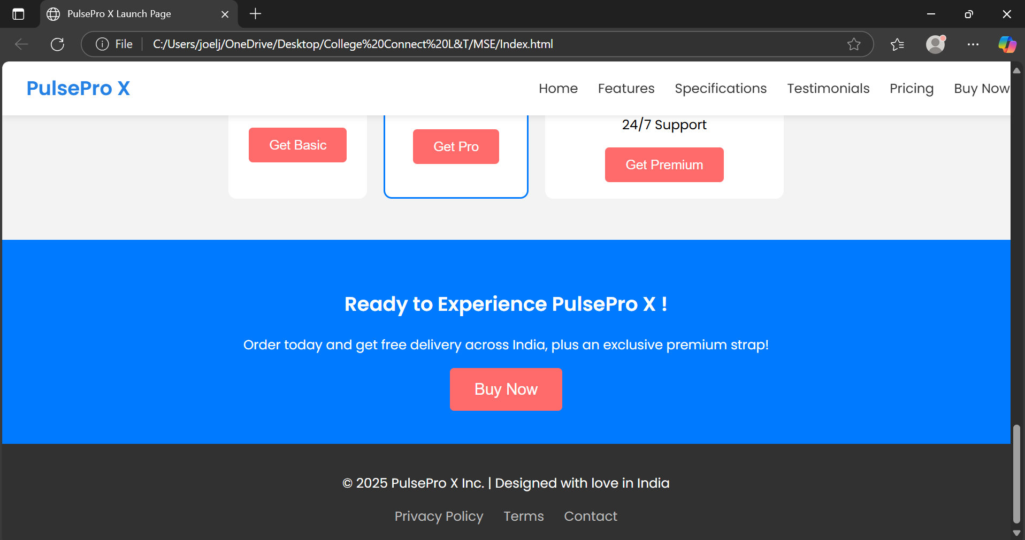

**11. Conclusion**

The Product launch page successfully meets its intended objectives by delivering a clean, responsive, and visually engaging interface that effectively showcases the product’s features, specifications, and pricing. Through the use of semantic HTML5 and CSS, the page ensures accessibility, ease of navigation, and adaptability across devices. The structured layout, coupled with strong call-to-action elements, creates a user-friendly experience that aligns with professional product marketing standards.

**12. References**

* L&T LMS: https://learn.lntedutech.com/Landing/MyCourse